**Table of Contents**

1. Introduction 2

2. Analysis 2

I. Definition 2

II. Methodology 2

III. Feasibility study 5

IV. Software Requirement Specification with MoSCoW prioritization 7

V. Use Case Diagram 11

VI. System Architecture 13

3. Design 16

4. Implementation/Coding 16

5. Testing 16

6. Other Project Issues 16

7. Conclusion 16

8. References 16

# Introduction

# Analysis

## Definition

An examination of data and facts to uncover and understand cause-effect relationship, thus providing basis for the problem solving and decision making. It is also known as the systematic way for examination of all the data and information about the project for making its existence in coming future and for getting its essential and important features.

(karamer, 2014)

## Methodology

It contain the methodology like Soft approach, hard approach, combine approach, PEST analysis, SWOT analysis, etc.

The methodology that I am using is **Hard Approach**. It can be used to address both qualitative and quantitative problems. This is step-by-step procedure, which can be iterative, and the process should be revised if new information comes to light ore later stage in the process changes the situational perspective.

I used this approach because it helps to identify the problem or opportunity. It describe the situation of the system that I am developing. It helps to know that the behaviors of the system in present and future. The main theme of using this approach is it follow and decide the particular route and monitor and evaluate the outcomes.

(manir, n.d.)

**Figure of hard approach**

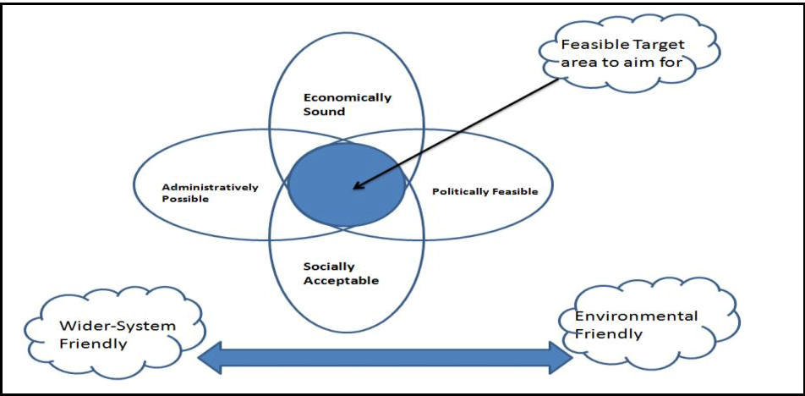

Figure 1: Figure of hard approach.

**Data flow Diagram (DFD):**

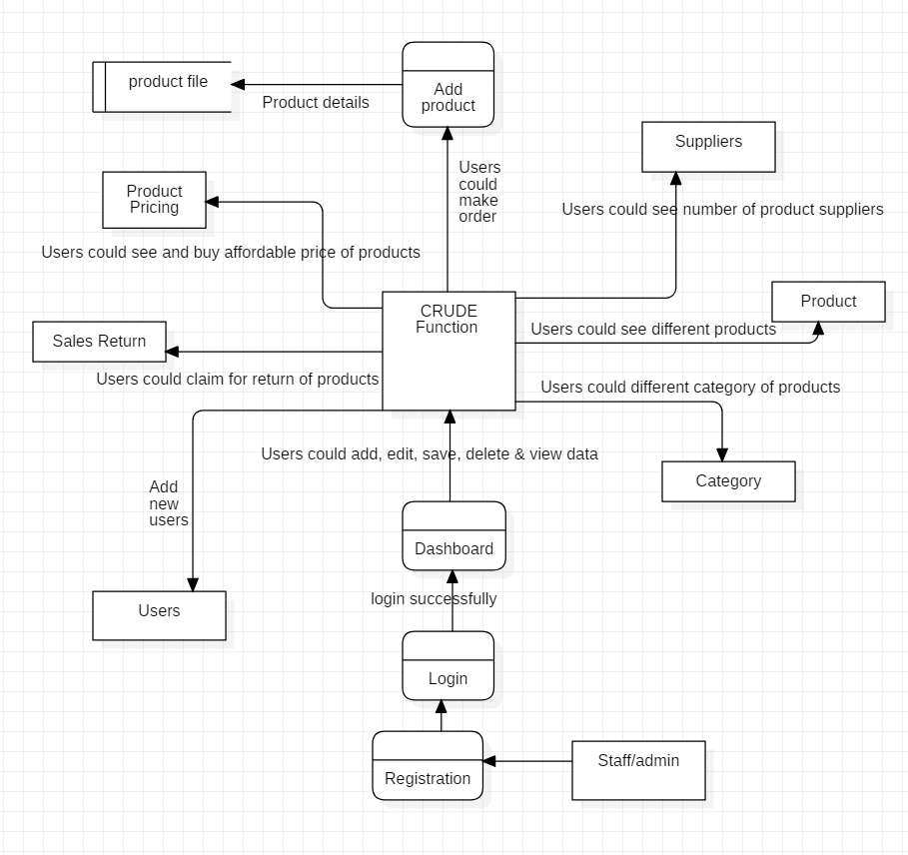

Figure 2: DFD

## Feasibility study

Feasible study is the very first design stage of the certain project, that bring together the elements or the main content of knowledge that indicate if a project is possible or not. It helps to the project whether the project is worthy or not. It is used to determine that if it is technical feasible, is feasible in its estimated cost, will be beneficial or not.

(Farooq, 2016)

**The Inventory Management system should be feasible in the following sectors. So all sector should study.**

1. **Social feasibility study:**

The affect which a developing project may have on the social system in the project environment is addressed in the social feasibility. The particular group or the category of the employee may not be available because of ambient social structure. The influence about the social status of the project to the participant should be evaluate for the compatibility.

1. **Economic feasibility study:**

This feasibility study tells about feasibility of the developing project to produce economic benefits. The economic feasibility of a project can also be evaluated by a breakeven analysis. It analysis the cost that is needed while developing the project.

1. **Legal feasibility study:**

Legal feasibility study about the project means whether the project that we are developing is legally approved by the government or not. If it is not legalize by the government it will not be essential.

1. **Political feasibility study:**

Most of the proposed project are dictated by the political consideration. So the terms and condition of the political sector should be agreed while developing the project because further the political factor will not be able to affect the developed project.

1. **Scheduling feasibility study:**

It is about the analyzation of the proposed project that is Inventory Management System for management of the time to complete it in given deadline. It the inventory management system is not completed in time it may create so many problems like.

1. **Technical feasibility study:**

It tells about the technical resources for the system that you are developing. Inventory Management System is desktop application we need to make sure that what kind of component it needs.

**Information Gathering:**

The information could be gathered for any tasks from different sources like observation, survey, interview, focus group, etc. Similarly, I have gathered information through survey for my task. The questions for my survey goes like:

1. What is the value of Inventory Management System in the market?
2. How many regular customers are there in the previous project?
3. Does the customers are giving the positive feedbacks?
4. Is there the possibility of long lasting of the project or not?

## Software Requirement Specification with MoSCoW prioritization

A software requirements specification (SRS) is all about detailed description of Inventory Management system to be developed with its functional and non-functional requirements. System Requirement Specification deals with agreement between Contractors and the Clients. (Krüger, 2018)

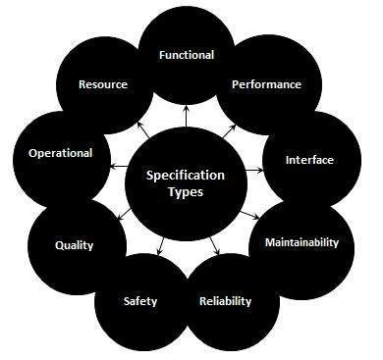

Figure 3: SRS.

**Mainly it contain Functional and Non-functional requirement which are illustrate below**

**Functional Requirement:**

The identification and declaration of the intended function of inventory management system and its component is called functional requirements. It define what a system is supposed to do. The early form of the functional requirement is system design. It can be related to both hardware, software or the both in term of calculation, technical detail, data manipulation and other specific functionality.

**Non-functional Requirement:**

Non-functional requirement (NFR) is a requirement that intend to judge the operation of a system, rather than its particular or the specific behaviors and functions. It basically define how a system is supposed to be. It have executive quality such as safety, security, as well as usability which are observed at run time and Evolutionary quality such as testability, maintainability, extensibility, scalability involved in the internal structure of the system.

**The identification of functional and non-functional requirement with MoSCoW prioritization is tabulate in the table below.**

In the table the indexes used for functional, non-function and MoSCoW are:

**M**: Most Have

**S**: Should Have

**C**: Could Have

**F**: Functional Requirement

**NF**: Non-functional Requirement

**Functional Requirements with MoSCoW prioritization:**

|  |  |  |  |  |
| --- | --- | --- | --- | --- |
| **S. No** | **Requirements** | **MoSCoW** | **Description** | **Dependencies** |
|  | Registration | **M** | User (Not for admin) should be registered in order to get access. | Independent |
|  | Login | **M** | Login is necessary to verify and validate the users (All the users). | F1 |
|  | Insert Product | **M** | Product are to be inserted by admin only to provide the available items for users. | F2 |
|  | Update Product | **S** | Product information should be able to be updated by the admin only. | F3 |
|  | Delete Product | **S** | Admin should be able to delete the unavailable items. | F3 |
|  | View Product Information | **M** | Both admin and users should be able to view product information. | F3 |
|  | Search Item | **M** | Product should be able to view information in search if the item exists. | F2 |
|  | Order Product | **M** | Users should be able to order the product they have booked. | F2, F7 |
|  | Dashboard | **S** | Dashboard should be available after the user authentication is verified. | Independent |
|  | CRUDE function | **S** | Users (All the users) should be able to edit their data or information. | F2 |
|  | Staff Review | **C** | Staff review is useful to know the product’s quality. | F2 |
|  | Generate receipt | **M** | Staff are provided bills after they buy the products. Billing is necessary for the users as a proof and also to have trust. | F9,F2 |
|  | Forgot Password | **C** | It is one of the good factor that increases the customer satisfaction. Staff sometimes forgot their passwords, in that case it is very useful. | F10 |
|  | Manage Inventory | **M** | Inventory system of the data should be managed in a proper way that make the business manage. | F3, F5, F9 |

**Non-Functional Requirements with MoSCoW prioritization:**

|  |  |  |  |
| --- | --- | --- | --- |
| **S. No** | **Requirements** | **MoSCoW** | **Description** |
|  | Security | **S** | Users should be provided security for their accounts, activities they perform, and also the data in the system. |
|  | Performance | **S** | User should not feel that the system (server) is slow. There are many options to increase the performance. |
|  | Availability | **S** | The system should be available to the users whenever they want. |
|  | Reliability | **S** | The system should be reliable to the users no matters what or how many time they performs any activities. |
|  | Maintainability | **S** | Software should be developed in a maintained form. So it can be easily configured and reused. |
|  | Usability | **S** | Software have to be usable to the users in order to have good quality. |
|  | Data Integrity | **S** | It is maintaining and assuring the accuracy and consistency of data over its entire life-cycle. |
|  | Supportability | **S** | The ability of technical support personnel to install, configure, and monitor the product. |

## Use Case Diagram

It is the kinds of dynamic diagram that show the behavior of the system that you have developed is called use case diagram. It helps to show the behavior and relationship between actors, system and use case. The main purpose of the use case diagram is to show who are using the system and interacting with the system that you we have create and what is the main aim they have to achieve from system. It helps to find the system functionality at analysis phase. This system separate the system into use case and the actors where actor represent as the user of system. (apploy, 2016)

The use case diagram contain the following components:

* **Actors**

Actor is denoted by the stick figure. Which denote the users of the system.

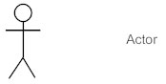

* **Use cases**

It provide the description of the process. And contain oval shave structure.

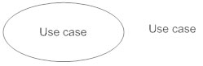

* **Relationship**

It show the relationship between the use case of the system and the actors.

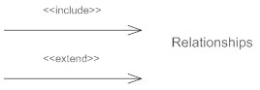

**Use case diagram**

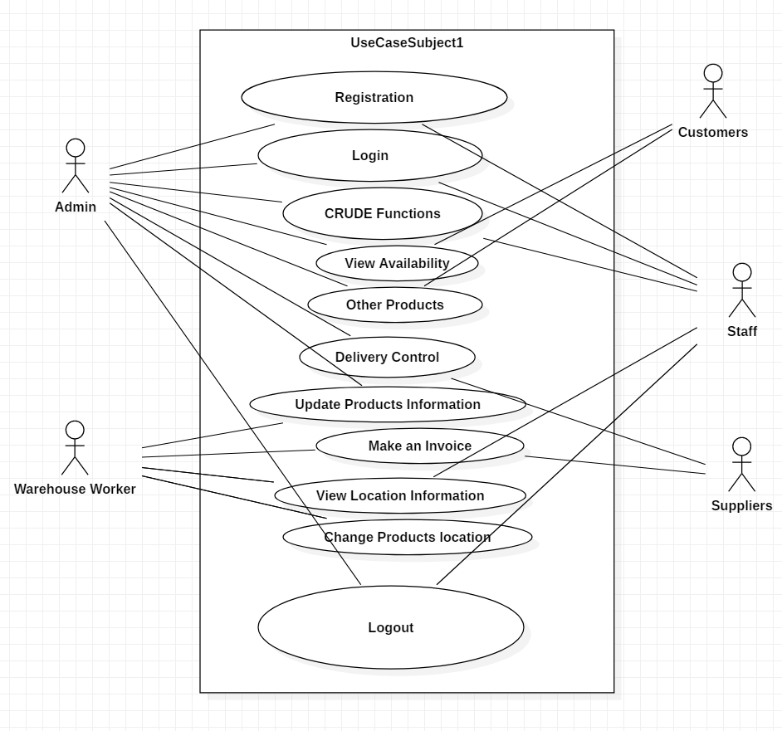

Figure 4: Use case diagram

## System Architecture

**Background of the project:**

For the management of medium and small scale business you have to develop secure Inventory Management System. In this system of management the staff or admin should be able to add or Update, Edit, Delete the data for the management of business. To access the system the user need to register for accessing the inventory management system then only you can be able to login the system. The dashboard of the management system require the options User, Products, Stocks, Suppliers, Categories, Purchase invoice, Sales, Product Pricing, Sales return, etc. On accessing or clicking these option every particular option must contain CRUDE function.

The user of the system can deal with other companies for the good supply. After the supply of the goods the owner company should be able to store the Product data, sales data, supply data and other through this system as well as able to print out the invoice of Product purchase through this Inventory Management system.

**Natural Language Analysis:**

The separation of noun and verb for the candidate class are tabulate in the table below:

|  |  |
| --- | --- |
| **Nouns** | **Verbs** |
| Business, Scale, Inventory, system, Login, dashboard, staffs, admin, Product pricing, sales, Stocks, Suppliers, Purchase invoice, option, companies, good supply, Product data, sales data, etc. | Develop, manage, register, category, sales return, function, store, purchase, print, supply, Add, Update, Delete, edit, create, etc. |

From above table of noun and verb we select the appropriate noun and verb for the construction of the Initial class diagram.

**Initial Class Diagram:**

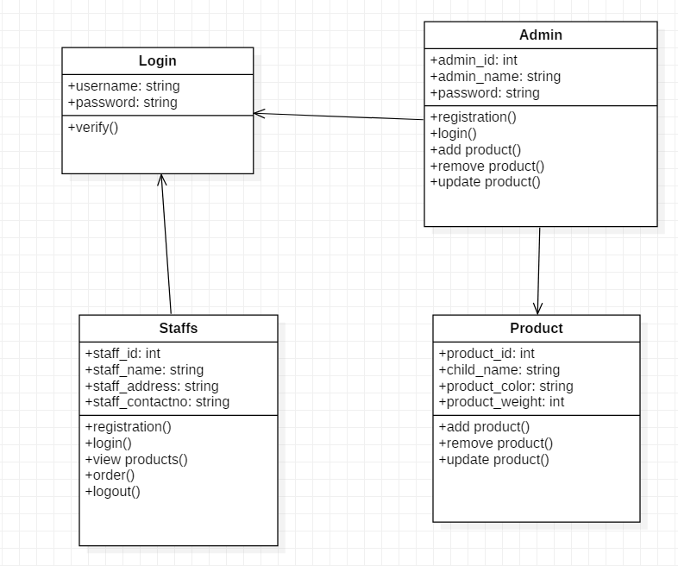

Figure 5: Initial class diagram

**System architecture definition:**

Inventory Management system use 3-tier architecture that have three layer which are Presentation layer, Application layer and database server. Presentation layer contain the PC, Tablet, Mobile, etc. and Application Layer that deals with the server. (Dale, 2017)

**The three-tier architecture have following goals:**

* The user application and the physical database are separated by the three-tier architecture.
* It helps to support DBMS characteristics.
* Program-data independence.
* It helps to support the multiple data of the system.

**System architecture diagram:**

[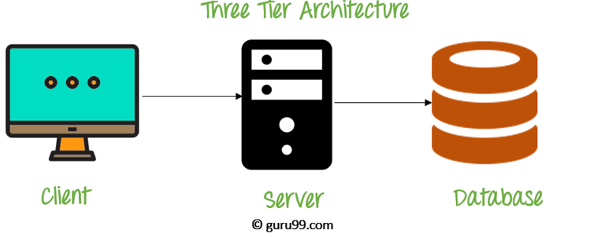](https://www.guru99.com/images/1/091318_0745_DBMSArchite3.png)

Figure 6: three-tier architecture

# Design

# Implementation/Coding

# Testing

# Other Project Issues

# Conclusion

# References

apploy, 2016. *www.smartdraw.com.* [Online]   
Available at: https://www.smartdraw.com/use-case-diagram

Dale, 2017. *www.techopedia.com.* [Online]   
Available at: https://www.techopedia.com/definition/24649/three-tier-architecture

Farooq, U., 2016. *www.businessstudynotes.com.* [Online]   
Available at: https://www.businessstudynotes.com/finance/project-management/types-feasibility-study/

karamer, 2014. *www.businessdictionary.com.* [Online]   
Available at: http://www.businessdictionary.com/definition/analysis.html

Krüger, N., 2018. *www.perforce.com.* [Online]   
Available at: https://www.perforce.com/blog/alm/how-write-software-requirements-specification-srs-document

manir, r., n.d. *www.twi-global.com.* [Online]   
Available at: https://www.twi-global.com/technical-knowledge/faqs/what-is-the-hard-systems-approach-to-problem-solving  
[Accessed 2013].